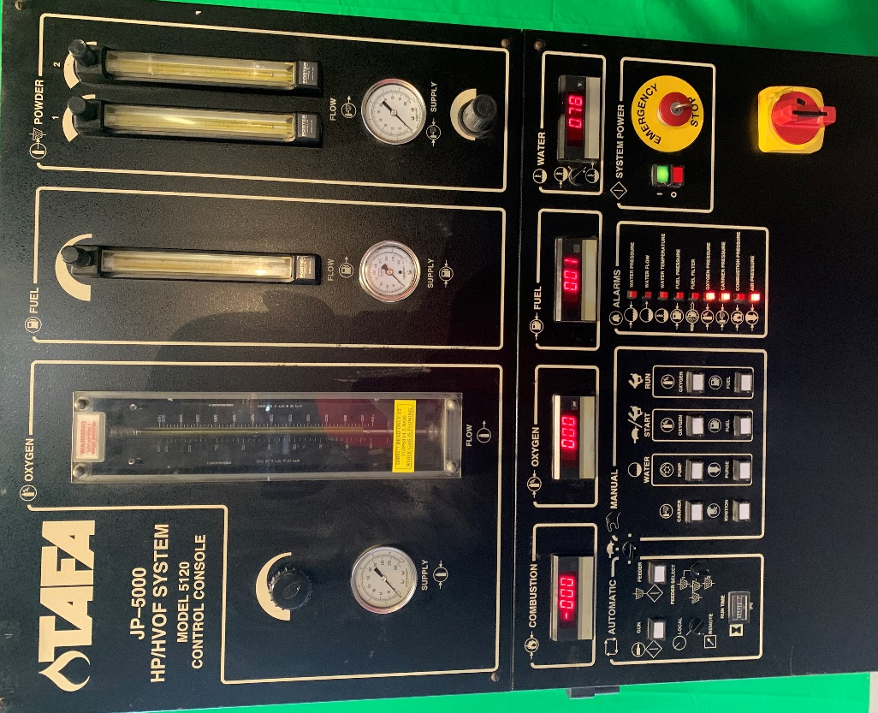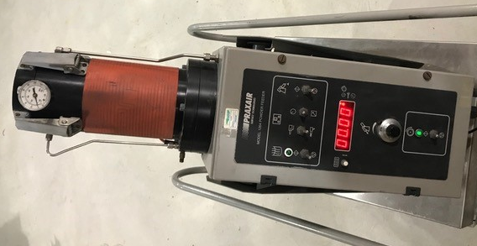
Praxair Model 5120 Console, actual photo Praxair 1264 powder feeder, file photo

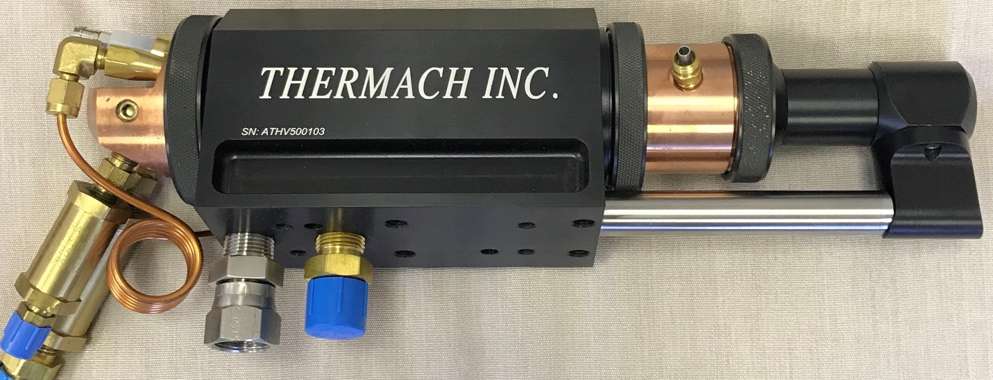
New Thermach direct replacement for JP5000 torch
Complete JP5000 system, includes all new hoses and cables (not shown), fully serviced, calibrated, and ready to go into production. Chiller not included.
$59, 750

